CR-05 - Goals and Outcomes
Progress the jurisdiction has made in carrying out its strategic plan and its action plan. 91.520(a)
This could be an overview that includes major initiatives and highlights that were proposed and executed throughout the program year.

The 2019 annual action plan represents the goals and accomplishments which were originally anticipated in the period July 2019 through June 2020, wrapping up the last year of the 2015-2019 strategic plan. On January 21, 2020, the Utah Department of Health activated its Department Operations Center in response to the evolving COVID-19 global pandemic, followed a week later by the federal declaration of a public health emergency. The pandemic quickly wreaked havoc on every aspect of plans worldwide; however, the participating jurisdictions of the Salt Lake Urban County and the Salt Lake County Consortium have demonstrated resilience and strength as the communities have adapted to meet evolving needs. Subsequently, although it was necessary to make adjustments to individual projects and activities, the overall goals related to housing and housing stability, economic opportunity and sustainability, stability and safety, and access to crisis services have continued to be prioritized. The following examples highlight some of the accomplishments towards the goals associated with the highest needs in PY2019.
HOUSING REHABILITATION: 35 rehabilitation projects have been completed in late 2020 through the Aging in Place Salt Lake program, utilizing $186,000 of HOME funds to leverage an investment of $750,000 of funding from the Federal Home Loan Bank of DesMoines. All 35 homes completed were occupied by elderly or a household with someone with a disability. The housing units were made fully accessible and livable. HOME funds also helped to facilitate the Lincoln Tower senior housing project, which rehabilitated 100 rental units for seniors, and was completed in October 2020. CDBG funds were instrumental in the rehab and accessibility of 126 homes, which preserved existing housing.
RENTAL HOUSING and ASSISTANCE: In the spring of 2019, the Sharon Gardens project was completed. Additional rental housing accomplishments were completed in the 2019 program year, but will be reflected in IDIS after July 2020 due to close-out dates. Early in 2020 the HiGrade apartments project (100 units) was completed; however, the project was not closed out until after July 1, 2020. The Cornell project (142 units) and the MODA project (45 units) were both completed in the spring of 2020 and closed out in the fall of 2020. The HUB of Opportunity (85 units) was completed in the summer of 2020, and was closed out in the fall of 2020. Salt Lake County also continued to support the stabilization of low-income families who homeless or at risk of homelessness through tenant-based rental assistance.
HOMEOWNERSHIP: Two Down Payment Assistance programs facilitated the dream of homeownership for 126 low-to-moderate income first time homebuyers.
INFRASTRUCTURE PROJECTS. Neighborhood revitalization and safety was the focus for four projects in the Urban County jurisdictions. ADA ramps increased accessibility in Midvale City. Safe access and walkability was facilitated through improved sidewalks in Kearns. New lighting helped transform a former industrial area into a safer, more livable, and more walkable residential neighborhood near the Meadowbrook Station Area (TOD) in South Salt Lake. New lighting and a culturally significant futsal court provide safety and greater recreation and fitness opportunities were provided for low-income families served by Sunnyvale Park in the heart of the refugee community in Millcreek City, and now children of refugee entrepreneurs have a place to play while parents farm and at the Sunnyvale Farmer’s Market – contributing to economic and socio-cultural well-being of these families.
CDBG funds also supported the work of 12 non-profit agencies to help people access crisis assistance, achieve stability and safety, and obtain economic stability.
Comparison of the proposed versus actual outcomes for each outcome measure submitted with the consolidated plan and explain, if applicable, why progress was not made toward meeting goals and objectives. 91.520(g)
Categories, priority levels, funding sources and amounts, outcomes/objectives, goal outcome indicators, units of measure, targets, actual outcomes/outputs, and percentage completed for each of the grantee’s program year goals.

Goal | Category | Source / Amount | Indicator | Unit of Measure | Expected – Strategic Plan | Actual – Strategic Plan | Percent Complete | Expected – Program Year | Actual – Program Year | Percent Complete
Decent Housing H-1: Housing Rehab & Accessibility | Affordable Housing | CDBG: $ / HOME: $ / ESG: $ | Homeowner Housing Added | Household Housing Unit |  | 4 |  | 0 | 4
Decent Housing H-1: Housing Rehab & Accessibility | Affordable Housing | CDBG: $ / HOME: $ / ESG: $ | Homeowner Housing Rehabilitated | Household Housing Unit | 1300 | 194 | 14.92% | 281 | 181 | 64.41%
Decent Housing H-2: Homeownership | Affordable Housing | CDBG: $ / HOME: $ / ESG: $ | Homeowner Housing Added | Household Housing Unit | 5 | 20 | 400.00% | 0 | 0
Decent Housing H-2: Homeownership | Affordable Housing | CDBG: $ / HOME: $ / ESG: $ | Homeowner Housing Rehabilitated | Household Housing Unit | 5 | 46 | 920.00%
Decent Housing H-2: Homeownership | Affordable Housing | CDBG: $ / HOME: $ / ESG: $ | Direct Financial Assistance to Homebuyers | Households Assisted | 40 | 4 | 10.00% | 157 | 4 | 2.55%
Decent Housing H-6: Rental Housing | Affordable Housing | CDBG: $ / HOME: $ / ESG: $ | Rental units constructed | Household Housing Unit | 100 | 58 | 58.00% | 290 | 58 | 20.00%
Decent Housing H-6: Rental Housing | Affordable Housing | CDBG: $ / HOME: $ / ESG: $ | Rental units rehabilitated | Household Housing Unit | 100 | 0 | 0.00% | 95 | 0 | 0.00%
Decent Housing H-7: Senior Housing | Affordable Housing | CDBG: $ / HOME: $0 / ESG: $ | Rental units constructed | Household Housing Unit | 60 | 58 | 96.67% | 58 | 58 | 100.00%
Decent Housing H-8: Special Needs Housing | Affordable Housing | CDBG: $ / HOME: $ / ESG: $ | Rental units constructed | Household Housing Unit | 20 | 58 | 290.00%
Decent Housing H-8: Special Needs Housing | Affordable Housing | CDBG: $ / HOME: $ / ESG: $ | Rental units rehabilitated | Household Housing Unit | 20 | 0 | 0.00%
Decent Housing Homeless and Special Needs -3 | Affordable Housing | CDBG: $ / HOME: $1780000 / ESG: $ | Rental units constructed | Household Housing Unit | 10 | 0 | 0.00% | 119 | 58 | 48.74%
Decent Housing Homeless and Special Needs -3 | Affordable Housing | CDBG: $ / HOME: $1780000 / ESG: $ | Rental units rehabilitated | Household Housing Unit | 10 | 0 | 0.00% | 95 | 0 | 0.00%
Decent Housing Homeless-1: Rental Housing | Affordable Housing | CDBG: $ / ESG: $ | Rental units constructed | Household Housing Unit | 20 | 0 | 0.00%
Decent Housing Homeless-2: Rental Assistance-RRH | Affordable Housing | CDBG: $ / HOME: $ / ESG: $ | Tenant-based rental assistance / Rapid Rehousing | Households Assisted | 295 | 142 | 48.14% | 250 | 142 | 56.80%
Economic Opportunity & Job Creation | Non-Housing Community Development | CDBG: $ / HOME: $ / ESG: $ | Public Facility or Infrastructure Activities other than Low/Moderate Income Housing Benefit | Persons Assisted | 0 | 183
Economic Opportunity & Job Creation | Non-Housing Community Development | CDBG: $ / HOME: $ / ESG: $ | Homeless Person Overnight Shelter | Persons Assisted | 0 | 0
Economic Opportunity & Job Creation | Non-Housing Community Development | CDBG: $ / HOME: $ / ESG: $ | Overnight/Emergency Shelter/Transitional Housing Beds added | Beds | 0 | 0
Economic Opportunity & Job Creation | Non-Housing Community Development | CDBG: $ / HOME: $ / ESG: $ | Jobs created/retained | Jobs | 100 | 0 | 0.00% | 5 | 0 | 0.00%
Economic Opportunity & Job Creation | Non-Housing Community Development | CDBG: $ / HOME: $ / ESG: $ | Businesses assisted | Businesses Assisted | 75 | 0 | 0.00% | 1 | 0 | 0.00%
Housing H-3: Social Services-Stability & Safety | Homeless  Non-Homeless Special Needs  Non-Housing Community Development | CDBG: $ / HOME: $ / ESG: $ | Public service activities other than Low/Moderate Income Housing Benefit | Persons Assisted | 1793 | 1196 | 66.70% | 1495 | 0 | 0.00%
Housing H-4: Social Services-Access to Crisis Serv | Non-Housing Community Development | CDBG: $ / HOME: $ / ESG: $ | Public Facility or Infrastructure Activities other than Low/Moderate Income Housing Benefit | Persons Assisted | 0 | 0
Housing H-4: Social Services-Access to Crisis Serv | Non-Housing Community Development | CDBG: $ / HOME: $ / ESG: $ | Public service activities other than Low/Moderate Income Housing Benefit | Persons Assisted | 20000 | 2052 | 10.26%
Housing H-4: Social Services-Access to Crisis Serv | Non-Housing Community Development | CDBG: $ / HOME: $ / ESG: $ | Public service activities for Low/Moderate Income Housing Benefit | Households Assisted | 625 | 0 | 0.00% | 396 | 0 | 0.00%
Housing H-4: Social Services-Access to Crisis Serv | Non-Housing Community Development | CDBG: $ / HOME: $ / ESG: $ | Homeless Person Overnight Shelter | Persons Assisted | 8352 | 771 | 9.23% | 1955 | 340 | 17.39%
Housing H-5: Social Services-Econ Independence | Non-Housing Community Development | CDBG: $ / HOME: $ / ESG: $ | Public Facility or Infrastructure Activities for Low/Moderate Income Housing Benefit | Households Assisted | 100 | 0 | 0.00%
Housing H-5: Social Services-Econ Independence | Non-Housing Community Development | CDBG: $ / HOME: $ / ESG: $ | Public service activities other than Low/Moderate Income Housing Benefit | Persons Assisted | 0 | 0 |  | 62 | 0 | 0.00%
Sustainable Living Environment CD-2 Infrastructure | Non-Housing Community Development | CDBG: $ / HOME: $ / ESG: $ | Public Facility or Infrastructure Activities other than Low/Moderate Income Housing Benefit | Persons Assisted | 10000 | 19389 | 193.89% | 2950 | 14501 | 491.56%
Sustainable Living Environment CD-3 Public Fac. | Homeless  Non-Homeless Special Needs  Non-Housing Community Development | CDBG: $ / HOME: $ / ESG: $ | Public Facility or Infrastructure Activities other than Low/Moderate Income Housing Benefit | Persons Assisted | 2486 | 5552 | 223.33% | 6299 | 3327 | 52.82%
Sustainable Living Environment CD-3 Public Fac. | Homeless  Non-Homeless Special Needs  Non-Housing Community Development | CDBG: $ / HOME: $ / ESG: $ | Homeless Person Overnight Shelter | Persons Assisted | 0 | 1306 |  | 0 | 54
Sustainable Living Environment CD-3 Public Fac. | Homeless  Non-Homeless Special Needs  Non-Housing Community Development | CDBG: $ / HOME: $ / ESG: $ | Overnight/Emergency Shelter/Transitional Housing Beds added | Beds | 0 | 0 |  | 0 | 0
Sustainable Living Environment CD-4 Neighborhood | Non-Housing Community Development | CDBG: $ / HOME: $ / ESG: $ | Public Facility or Infrastructure Activities other than Low/Moderate Income Housing Benefit | Persons Assisted | 5000 | 0 | 0.00%
Sustainable Living Environment CD-4 Neighborhood | Non-Housing Community Development | CDBG: $ / HOME: $ / ESG: $ | Public Facility or Infrastructure Activities for Low/Moderate Income Housing Benefit | Households Assisted | 0 | 0
Table 1 - Accomplishments – Program Year & Strategic Plan to Date

Assess how the jurisdiction’s use of funds, particularly CDBG, addresses the priorities and specific objectives identified in the plan, giving special attention to the highest priority activities identified.
The 2019 Action Plan called for CDBG, HOME, and ESG funds to be made available for a variety of eligible activities, all of which are aligned with the County’s priorities related to Housing and Housing Stability. The Salt Lake County Housing and Community Development Division adopted the framework of the Social Determinants of Health as a metric which effectively gauges both health and housing stability outcomes. By strategically allocating funds to positively impact social and economic conditions in each of the domains of the Social Determinants of Health, there is corresponding research which supports the expectation that housing stability will improve along with health outcomes. Therefore, for the 2019-2020 program year, projects which were funded demonstrated the capacity to carry out activities that improve conditions in one or more of the six domains: Economic Stability; Education; Community and Social Context; Neighborhood and Physical Environment; Health Care Systems; and/or Food.
HOME funds addressed the priority needs of Housing Opportunities, Rental Assistance, Rental Housing, and Homeownership. These effected change in the domains of Neighborhood and Physical Environment. The GHHI and Lead Safe Housing programs contributed to improvements in the Health Care System domain. Over the next three and half years work that has begun will be completed, as 260 housing units will be made lead safe and healthy. In 2019 work was continued with the medical providers like University of Utah Health Plans, Select Health, Salt Lake County Health Department Asthma program to assist those with severe asthma.
ESG Funds facilitated Rental Assistance, Rapid Rehousing, and Access to Crisis Services, which also can be measured in the domain of Neighborhood and Physical Environment.
CDBG funds were used to address the priority needs of: Housing Opportunities; Stability and Safety; Homeownership; Economic Independence; Infrastructure Improvements; Creating Economic Opportunity; Access to Crisis Services; and Public Facility Improvements. These activities impacted all six domains of the Social Determinants of Health.
It is anticipated that the implementation of this strategy - the integration of the research-backed metrics of health and housing stability into the prioritized goals of the annual action plan - will facilitate data-informed decision-making for future investments of CDBG and other public and private resources.
CR05 Accomplishments Comparison
These tables reflect accomplishments of projects which are tied to multiple HUD Goals, but which have been reported as unduplicated counts. Therefore, accomplishments may be reflected in a different goal than was used for original estimates.

CR-10 - Racial and Ethnic composition of families assisted
Describe the families assisted (including the racial and ethnic status of families assisted). 91.520(a)

 | CDBG | HOME | ESG
White | 3,951 | 643 | 4,682
Black or African American | 337 | 30 | 793
Asian | 109 | 2 | 67
American Indian or American Native | 124 | 39 | 400
Native Hawaiian or Other Pacific Islander | 85 | 11 | 158

Total | 4,606 | 725 | 6,100

Hispanic | 543 | 171 | 4,552
Not Hispanic | 4,063 | 554 | 1,548

Table 2 – Table of assistance to racial and ethnic populations by source of funds

Narrative
The information used to compare how well Salt Lake County is performing in serving racial and ethnic families comes from Quick Facts, from the United States Census for states and counties with population of 5,000 or more. These are estimates as of July 1,2019
The CDBG program overall assessment of minority populations served is 14.2% which is higher than the percent of the minority population for the County is 10%. However, the percent of those identifying as Hispanic that were served 13.36% is lower than the county Hispanic population which is 18.8%.
For the HOME Program, the overall assessment of minority populations served is 24% which is higher than the percentages of minorities, 10% of the population. For those identifying as Hispanic, those served were 5% of the population which is lower than the county population identifying as Hispanics which is 18.8%.
For the ESG program, this reported information comes from the ESG CAPER report. The numbers do not reflect the information for multiple races, clients refused to provide information, or data not collected. Agencies do their best to collect this information and report accurately.
Efforts being made to increase services to the underserved populations include:
1. Specific outreach provisions in the contracts for services to seek out those who are underserved.
2. Monitoring of contracts and program outcomes for services to underrepresented populations.
3. Requiring numbers of those served be included quarterly reports.
4. During the annual community needs assessment process make concerted effort to reach out to underrepresented populations to educate them on services
5. Partner, collaborate, and fund agencies that serve underrepresented populations.
6. Improve the Citizen Participation plan to strengthen sections that pertain to education and outreach to underrepresented populations.
The Salt Lake County lead safe housing program outreach targets low income neighborhoods with housing built before 1950. Outreach activities include working with a variety of community groups with representation from households with different racial and ethnic compositions. Examples of outreach activities include the “Party In The Park” held in October 2019, which was an event held at a park on the west side of Salt Lake City. This neighborhood has a high concentration of families from the Hispanic and Pacific Island communities. Over 500 people attended the event which provided information about lead and healthy homes. Helmets were distributed to children and trees were given away to be planted at homes in the neighborhood.

CR-15 - Resources and Investments 91.520(a)
Identify the resources made available
Source of Funds | Source | Resources Made Available | Amount Expended During Program Year
CDBG | public - federal | 3,065,001 | 3,960,747
HOME | public - federal | 4,024,010 | 1,871,875,510
ESG | public - federal | 214,436 | 197,981
Table 3 - Resources Made Available

Narrative
The table above reflects the expected amount available from each funding source based on planning for FY20 awards, compared to the actual amount expended. Actual expenditures include reimbursements for projects which were contracted in the prior year but completed in the 2019 program year. CDBG projects which were contracted prior to July 2019 and completed between July 2019 and June 2020 account for the $895,746 difference. The Road Home was not able to fully expend the ESG allocation for Rapid Re-housing due challenges which have been since resolved, resulting in expenditures $16,455 less than anticipated between July 2019 and June 2020.
The County works in concert with the nonprofit social services providers to identify gaps in service delivery and enhance coordination among providers. As the regional government for the Salt Lake Valley, Salt Lake County understands that a collaborative, thoughtful approach to regional planning will help us maintain the small town feel that sets us apart from other metropolitan regions. The Office of Regional Development works collaboratively with state and local governments, businesses, and community organizations to accomplish goals today so we can have “The Future We Choose” for our families and our homes. The Program Managers from Community Development, Housing, Green & Healthy Homes Initiative, Social Services Block Grant, the Lead Program, AmeriCorps, and Homeless Services all participate along with the Division Executives in coordination, issue identification and program implementation for the effective use of resources. This helps eliminate the duplication of funding and ensures the County can receive the greatest benefit from the limited resources available from the County and from Federal and State Grants. This effort meets goal #1 of the Fair Housing Equity and Impediments Action Plan – Addressing issues on a regional level.

Identify the geographic distribution and location of investments
Target Area | Planned Percentage of Allocation | Actual Percentage of Allocation | Narrative Description
Table 4 – Identify the geographic distribution and location of investments

Narrative
Salt Lake County HOME Consortium consists of five of the six Entitlement Cities, the 11 Urban County Participating Cities, 5 Metro Townships and the Unincorporated Areas of Salt Lake County. Salt Lake City is not included in the Consortium or Urban County. This distribution of HOME funds is for the entire Salt Lake County geographic boundaries except for Salt Lake City proper who has their own HOME allocation.
The investment of HOME funds in the south and southwest part of the county continues to be challenging. It is an increasingly affluent area of the county that has seen significant growth.
The Urban County is comprised of five Metro Townships, the unincorporated area of the County and eleven incorporated cities including Alta, Bluffdale, Cottonwood Heights, Draper, Herriman, Holladay, Midvale, Millcreek, Murray, Riverton, and South Salt Lake. The cities range in population from the Town of Alta at of 383 to Millcreek City at 62,532. Continued coordination takes place with the urban county entities with both the hard costs and soft cost allocation of CDBG funds that. The County administers those funds but does so through an allocation process that includes representation of the various entities included in the Urban County.

Leveraging
Explain how federal funds leveraged additional resources (private, state and local funds), including a description of how matching requirements were satisfied, as well as how any publicly owned land or property located within the jurisdiction that were used to address the needs identified in the plan.
In 2019 Salt Lake County through its Aging Place program completed a complete retrofit of 35 homes, to fund this program Salt Lake County received a grant from Federal Home Bank of DesMoines of $750,000 and committed $185,000 of HOME funds to the project. The $750,000 is the match for this year HOME funds.
Non-profit agencies which provided public services activities with CDBG funds in the 2019 program year, leveraged their awards with an additional $5,454.598 in federal, state, local, and private resources.
Non-profit agencies which were awarded ESG funds in the 2019 program year reported $188,522.86 in matching funds.
It is anticipated that as the 16 projects are completed which were funded with CDBG in the 2019 program year for housing, facility improvements, and insfrastructure improvements, an additional $9,638,970 will be leveraged.
$151,317 of in-kind programming contributions leveraged County resources in the development of the SAMi application for the System Navigator Program during the 2019 program year.
The Emergency Solutions Grant requires a 100% match. Each of the agencies receiving ESG dollars leveraged at the required 100%. Specific ESG matching sources include Pamela Atkinson Housing Trust Funds, Utah Critical Needs funds from the State of Utah, County General Funds, and private donations. The County matches the administrative portion of this grant with County general fund dollars.
Utah State’s Olene Walker Housing Loan Fund is one of the largest affordable housing loan funding tools for affordable housing development During this past year, the fund loaned out over $2,500,000 to construct 159 units of affordable housing in Salt Lake County.
Salt Lake county is responsible for coordination of the HUD CoC Grant application for the Salt Lake County Continuum of Care. The applications and resulting funding provides approximately $8,000,000 of annual funding for local homeless housing and service programs.
As a result of the Coronavirus and the funding through the CARES Act, the State of Utah, and Salt Lake County began a rental assistance, mortgage and landlord assistant program for the residents of the County.

Fiscal Year Summary – HOME Match
1. Excess match from prior Federal fiscal year | 352,791
2. Match contributed during current Federal fiscal year | 750,000
3. Total match available for current Federal fiscal year (Line 1 plus Line 2) | 1,102,791
4. Match liability for current Federal fiscal year | 412,870
5. Excess match carried over to next Federal fiscal year (Line 3 minus Line 4) | 689,921
Table 5 – Fiscal Year Summary - HOME Match Report

Match Contribution for the Federal Fiscal Year
Project No. or Other ID | Date of Contribution | Cash  (non-Federal sources) | Foregone Taxes, Fees, Charges | Appraised Land/Real Property | Required Infrastructure | Site Preparation, Construction Materials, Donated labor | Bond Financing | Total Match
Aging in Place Salt Lake | 07/01/2019 | 750,000 | 0 | 0 | 0 | 0 | 0 | 750,000
Table 6 – Match Contribution for the Federal Fiscal Year

HOME MBE/WBE report
Program Income – Enter the program amounts for the reporting period
Balance on hand at begin-ning of reporting period  $ | Amount received during reporting period  $ | Total amount expended during reporting period  $ | Amount expended for TBRA  $ | Balance on hand at end of reporting period  $
794,202 | 302,277 | 302,277 | 100,000 | 794,202
Table 7 – Program Income

Minority Business Enterprises and Women Business Enterprises – Indicate the number and dollar value of contracts for HOME projects completed during the reporting period

 | Total | Minority Business Enterprises |  |  |  | White Non-Hispanic
 |  | Alaskan Native or American Indian | Asian or Pacific Islander | Black Non-Hispanic | Hispanic

Contracts
Dollar Amount | 132,916 | 132,916 | 0 | 0 | 0 | 0
Number | 6 | 0 | 0 | 0 | 0 | 6

Sub-Contracts
Number | 0 | 0 | 0 | 0 | 0 | 0
Dollar Amount | 0 | 0 | 0 | 0 | 0 | 0

 | Total | Women Business Enterprises | Male

Contracts
Dollar Amount | 132,916 | 0 | 132,916
Number | 6 | 0 | 6

Sub-Contracts
Number | 0 | 0 | 0
Dollar Amount | 0 | 0 | 0
Table 8 - Minority Business and Women Business Enterprises

Minority Owners of Rental Property – Indicate the number of HOME assisted rental property owners and the total amount of HOME funds in these rental properties assisted

 | Total | Minority Property Owners |  |  |  | White Non-Hispanic
 |  | Alaskan Native or American Indian | Asian or Pacific Islander | Black Non-Hispanic | Hispanic
Number | 0 | 0 | 0 | 0 | 0 | 0
Dollar Amount | 0 | 0 | 0 | 0 | 0 | 0
Table 9 – Minority Owners of Rental Property

Relocation and Real Property Acquisition – Indicate the number of persons displaced, the cost of relocation payments, the number of parcels acquired, and the cost of acquisition

Parcels Acquired | 0 | 0
Businesses Displaced | 0 | 0
Nonprofit Organizations Displaced | 0 | 0
Households Temporarily Relocated, not Displaced | 0 | 0

Households Displaced | Total | Minority Property Enterprises |  |  |  | White Non-Hispanic
 |  | Alaskan Native or American Indian | Asian or Pacific Islander | Black Non-Hispanic | Hispanic
Number | 0 | 0 | 0 | 0 | 0 | 0
Cost | 0 | 0 | 0 | 0 | 0 | 0
Table 10 – Relocation and Real Property Acquisition

CR-20 - Affordable Housing 91.520(b)
Evaluation of the jurisdiction's progress in providing affordable housing, including the number and types of families served, the number of extremely low-income, low-income, moderate-income, and middle-income persons served.

 | One-Year Goal | Actual
Number of Homeless households to be provided affordable housing units | 200 | 0
Number of Non-Homeless households to be provided affordable housing units | 362 | 142
Number of Special-Needs households to be provided affordable housing units | 219 | 58
Total | 781 | 200
Table 11 – Number of Households

 | One-Year Goal | Actual
Number of households supported through Rental Assistance | 100 | 142
Number of households supported through The Production of New Units | 292 | 58
Number of households supported through Rehab of Existing Units | 386 | 181
Number of households supported through Acquisition of Existing Units | 3 | 0
Total | 781 | 381
Table 12 – Number of Households Supported

Discuss the difference between goals and outcomes and problems encountered in meeting these goals.
Four rental housing projects were completed during the performance period of this grant, but were not closed out in IDIS to be able to be counted. One rental housing project was closed in this period, Sharon Gardens with 58 units of senior housing. Three additional projects will start at the end of 2020, and one purchase and rehabilitation of a 100-unit senior housing project will be completed by the end of 2020. 35 mobile homes were severely damaged by an earthquake in March 2020. All were fully restored with the help of $100,000 in Homes funds and technical support for this effort by West Valley City.
Discuss how these outcomes will impact future annual action plans.
Salt Lake County will continue to support the development and construction of affordable housing projects as well the rehabilitation of existing rental housing projects. Using RDA funds, the County will develop 5 idea houses in Magna next year which will be a model to the community on how homes and neighborhoods be improved. In addition, 30 homes will be retrofitted, 20 of which will be a complete retrofit to make them fully accessible for an Aging IN place program. Salt Lake County is applying for the 2020 Healthy Homes and Weatherization Cooperation Demonstration Grant for $1,000,000. Utah Community Action Weatherization and Salt Lake County have formed a partnership to implement the Healthy Housing and Weatherization Cooperation Demonstration project to make a least 120 housing units energy efficient, radon gas hazard free, lead based paint hazard safe and free from respiratory irritants that exacerbate asthma and COPD. Through zoning changes, Salt Lake County will work on the implementation on the development of Accessory Dwelling Units (ADU’s) to more efficiently create new affordable housing units by using existing properties.
Include the number of extremely low-income, low-income, and moderate-income persons served by each activity where information on income by family size is required to determine the eligibility of the activity.

Number of Households Served | CDBG Actual | HOME Actual
Extremely Low-income | 0 | 142
Low-income | 0 | 58
Moderate-income | 0 | 4
Total | 0 | 204
Table 13 – Number of Households Served

Narrative Information
The complete retrofit of 35 homes was completed, which were occupied by seniors and persons with disabilities. Out of the 35 homes, 32 were occupied by households at or below 60% of ami. In the 2019 program year an investment of funding of $1 million was made to the Lincoln Towers Senior Housing Apartments for the rehabilitation of 90 units. This project substantially improved the livability of this 40 plus year old apartment complex. Salt Lake County and Salt Lake City partnered on this tax credit rehabilitation.

CR-25 - Homeless and Other Special Needs 91.220(d, e); 91.320(d, e); 91.520(c)
Evaluate the jurisdiction’s progress in meeting its specific objectives for reducing and ending homelessness through:
Reaching out to homeless persons (especially unsheltered persons) and assessing their individual needs
The Coordinated Entry System (CES) Task Group was established as part of the Salt Lake Valley Coalition to End Homelessness (SLVCEH). The CES Task Group includes a variety of individuals representing various elements of the coordinated entry system throughout Salt Lake County. The group meets at least monthly and has finalized the Coordinated Entry standards to assist with housing placements for homeless persons. The community assessment process prioritizes households in most need and ensures services are received in a timely manner by using information gathered from the housing needs assessment tool (VI-SPDAT). Additionally, three weekly “Housing Triage” meetings are held with providers to review the community “by name list” and facilitate the prioritization for housing referrals and to help ensure services are received in a timely manner for families, chronic and/or vulnerable singles, and Veterans.
Access Points into the CES are found throughout Salt Lake County, based upon a “no wrong door” model, including resource centers. Access is also possible via a phone line for those who are unable to physically get to an Access Point. The phone line is operated by Utah Community Action, who manages diversion and coordinated intake at each of the homeless resource centers.
Street Outreach teams work to ensure that services are available to those unsheltered individuals and households who are least likely to apply for services. Known as a “mobile” access point into Coordinated Entry, Outreach teams are trained to conduct screenings and housing needs assessments (VI-SPDAT and full SPDAT) for those who are unsheltered. Since many unsheltered and chronically homeless people will initially decline assistance, mobile outreach teams will engage with these individuals over an extended period in an effort to get them connected with services.
The Point in Time Count conducted at the end of January provides the community with baseline demographic data. Our community uses the data to inform funding decisions and to determine what programs are needed.
The Crisis Response Core Function Group of the SLVCEH works to connect clients with crisis response services that will support their efforts to find safety and security, maintain stable housing, and make homelessness rare, brief, and non-recurring. Their work has included integrating data into planning efforts, analyzing racial disparities, and increasing access to transportation. Moving forward they plan to enhance information and services for families and aging populations.
The Client Focus Core Function Group of the SLVCEH focuses on establishing meaningful opportunities for those experiencing homelessness to provide feedback and input in system planning and design. This group will establish a feedback structure for clients to provide information about how they access services and what additional services would meet their needs.
Persons experiencing homelessness and individuals who are formerly homeless are invited to all of the SLVCEH meetings to provide input and feedback.
Addressing the emergency shelter and transitional housing needs of homeless persons
Our community has recently shifted from one main emergency shelter to a smaller, scattered site, low barrier, resource center model, which was designed to better address the emergency shelter needs of those experiencing homelessness.
In addition to the emergency shelter options within the community, several providers offer transitional housing options for youth, persons experiencing family violence, those involved in substance abuse treatment programs, and veterans. These programs provide targeted services for the populations they serve.
As part of our community response to COVID-19 we established the Stay Home, Stay Safe Hotel for high-risk individuals experiencing homelessness. This provided an alternate emergency shelter option for those with vulnerabilities that may make them more likely to contract COVID-19. This program targeted households containing a person aged 60 years of age or older and those with an underlying health condition as outlined by the CDC and Health Department.

Service providers within the jurisdiction work to address the emergency shelter and transitional housing needs of homeless persons by:
1. Analyzing system performance by utilizing HMIS data on an on-going basis
2. Using reports, such as, HIC, PIT, and LSA reports to track length of time spent homeless and in shelters to better understand inflow and outflow capacity
3. Most agencies utilize a Housing First model
4. Connecting clients to permanent housing as quickly as possible using programs such as RRH
5. Utilizing progressive engagement to ensure housing stability; all homeless families are offered RRH assistance
6. Having staff dedicated to managing and maintaining landlord relationships
7. The front line, intake staff of agencies receive ongoing training on trauma informed care, motivational interviewing, and population specific training for the most vulnerable populations.
8. Clients have diversion/housing problem solving conversations prior to shelter entry to help persons avoid an emergency shelter stay if possible.
It is a goal of the community that stays in shelter and transitional housing are brief and connections to permanent housing are a priority. Our System Performance Measures indicate that those staying in emergency shelter and transitional housing are staying in these homeless projects for less time than they were in the previous year. This indicates that people are moving into more stable housing options more quickly.
Helping low-income individuals and families avoid becoming homeless, especially extremely low-income individuals and families and those who are: likely to become homeless after being discharged from publicly funded institutions and systems of care (such as health care facilities, mental health facilities, foster care and other youth facilities, and corrections programs and institutions); and, receiving assistance from public or private agencies that address housing, health, social services, employment, education, or youth needs
Our strategy to reduce first time homelessness includes comparing annual numbers to understand trends, strengthening our prevention & diversion programs, & sharing data on risk factors with partner systems such as State employment, mainstream resources, food pantries, housing authorities & others who can target their resources to those at risk of homelessness. Local programs include:
- Prioritizing rehouses/housing stability.
- YWCA provides domestic violence survivors with flexible financial assistance to help avoid homelessness by obtaining or maintaining housing, & other support services.
- VA Supportive Services for Veteran Families (SSVF) helps people stay housed.
- Service providers reduce/eliminate barriers to services through the provision of supportive employment services
- Landlord Tenant Mediation to prevent evictions & ensure tenants understand their rights.
- SLCo Jail treatment program which aims to identify those at risk of homelessness & connect them with treatment.
- Expanded access to detox beds & inpatient substance abuse treatment which provide immediate diversion from shelter
Our System Performance Measures indicate that the amount of people entering our system who are considered homeless for the first time have decreased from the previous reporting period. We are successfully diverting or preventing homelessness for members of our community.
Utah Community Action began utilizes diversion services at the three resource centers. Assessments of clients are used to determine service needs and where possible, utilize resources other than the emergency shelter. Part of the assessment is a housing problem solving conversation that works to connect those presenting for services with family, friends, or landlord mediation to help them return to their previous housing situation if safe.
The CoC coordinates with publicly funded institutions to ensure that individuals are not discharged from systems of care such as foster care, health care, mental health care, or a correctional facility, directly to the street. Within Salt Lake County, regular coordination occurs between Social Services (Youth Services, Behavioral Health, Adult & Aging Services), SLCo Jail, Criminal Justice Advisory Group - working group - intersects of homelessness and criminal justice system, Health Department, and Housing and Community Development to identify necessary resources for those exiting systems of care.
The CoC coordinates with education providers and liaisons to ensure that youth have the educational resources they need. Youth employment programs have been established to ensure youth have job skills and opportunities.
The CoC coordinates with state WIA provider on job placement, training services, & administration of TANF, SNAP, GA, & Medicaid. All CoC funded projects refer to WIA & additional WIA services are offered at the resource centers. Homeless Youth providers refer to WIOA, which allows youth to continue their education, seek employment & gain skills. VA outreach programs for homeless veterans include referrals for employment. Recently, the efforts have been expanded as DWS has begun to offer employment services on-site at various agencies and shelter sites.
Helping homeless persons (especially chronically homeless individuals and families, families with children, veterans and their families, and unaccompanied youth) make the transition to permanent housing and independent living, including shortening the period of time that individuals and families experience homelessness, facilitating access for homeless individuals and families to affordable housing units, and preventing individuals and families who were recently homeless from becoming homeless again
As part of the Coordinated Entry process, case managers working with households experiencing homelessness maintain regular contact with those households along their path towards self-sufficiency. Households are encouraged to rapidly resolve their homelessness on their own with relatively few resources provided initially or avoid entering homelessness altogether. As needed and as more barriers are identified, households work with case management to access additional resources at any point during their episode of homelessness. Clients with extensive histories of homelessness and high scores on needs assessment tools will have priority access to available housing resources.
The CoC utilizes system performance measure reports to track the length of time individuals and families remain homeless. Using the data provided by the reports, and along with additional information that describes the needs of the community, the following are additional ways in which our CoC service providers help persons experiencing homelessness transition to housing and not return.
Our System Performance Measures indicate that of those that exit our system to a permanent housing destination or those that retain their permanent housing do so at the rate of 93%. This measure has been steady for a number of years and indicate the stabilizing effect of
1. We have increased RRH efforts using TANF, CoC and ESG dollars. We are working to improve efficiency and effectiveness of RRH through lessons learned from best practices.
2. Service providers are guided by the principles of Progressive Engagement for families and increased case management.
3. We adopted prioritization guidance for PSH projects, giving priority to those who are most vulnerable, those with the highest service needs, and the longest histories of homelessness.
4. We adopted the use of VI-SPDAT assessment as one part of the procedure for placing CH persons in housing.
The CoC is working with other partners on a state-wide level to address other issues that impact individuals who are experiencing homelessness. Those partners, who have all shown a commitment to reducing the barriers to obtain and retain housing include: private and public state-wide funders, mental health providers, legislators and other elected officials and policy makers, those in criminal justice, health care providers, and housing advocates and developers.
The CoC is also a part of a state-wide effort to increase the number of affordable housing units available, with a focus on reducing barriers, which will lead to the ability to house more individuals and families.
The Salt Lake Valley Coalition to End Homelessness works to align multiple funding streams for efforts to quickly rehouse homeless individuals and families while minimizing the trauma and dislocation caused to homeless individuals, families, and communities, promotes access to and effective utilization of mainstream programs by homeless individuals and families, optimizes self-sufficiency among individuals and families experiencing homelessness, reinforces an overall system planning effort which includes all resources, stakeholders, and funding, and provides multiple opportunities for client input and feedback.

CR-30 - Public Housing 91.220(h); 91.320(j)
Actions taken to address the needs of public housing
Housing Connect works to preserve and improve existing units through the preventative maintenance and capital fund programs. While Housing Connect is able to address health and safety items and routine repairs we continue to have a backlog of capital needs exceeding 2.5 million dollars. To address this issue Housing Connect has applied to transition 457 units to HUD's Rental Assistance Demonstration program. This will provide a way to rehabilitate or repair units by leveraging public and/or private debt and equity without depending on additional money from the government. The remaining 127 units have been approved for Section 18 demolition/disposition through HUD. Proceeds from sales will be used for affordable housing activities.
To prevent and reduce crime, Housing Connect contracts with the Unified Police Department to provide community policing in all of its developments. Housing Connect has implemented smoke free policies within all public housing and works to develop service components for residents to promote self-sufficiency so they may maintain their apartments independently.
Actions taken to encourage public housing residents to become more involved in management and participate in homeownership
Housing Connect works to increase resident involvement in program and policy decisions. Residents receiving rental assistance from Housing Connect have the opportunity to participate on Housing Connect’s Resident Advisory Board and Board of Commissioners where they provide input into the administration of the agency. This input helps to ensure that policies are balanced and serve the needs and interests of residents, Housing Connect, and the community.
Residents participating in the agency’s Housing Choice Voucher or Public Housing programs also have the opportunity to participate in the Family Self-Sufficiency program which provides individualized case management to support goals such as employment, education and homeownership.
In addition to programs implemented by Housing Connect, residents are also eligible for Section 3 when applying for positions, a status which many public employers prioritize when hiring.
Actions taken to provide assistance to troubled PHAs
Salt Lake County does not have any PHA's that have been identified or designated as troubled.

CR-35 - Other Actions 91.220(j)-(k); 91.320(i)-(j)
Actions taken to remove or ameliorate the negative effects of public policies that serve as barriers to affordable housing such as land use controls, tax policies affecting land, zoning ordinances, building codes, fees and charges, growth limitations, and policies affecting the return on residential investment. 91.220 (j); 91.320 (i)
Over the past two years, the issues of affordable housing and housing affordability have received increased attention from the state legislature, city and county policymakers, non-profit advocates, developers, and the business community (Salt Lake Area Chamber of Commerce).The increased concern was prompted by a growing drug and crime problems with Salt Lake City homeless population and the rapidly rising prices for both homes and rental units. In response, the 2019 Utah Legislature passed SB 34. SB 34 ties local transportation funds to the adoption by cities and counties of measures to increase housing affordability. By late 2019 nearly all major cities had adopted three or four of 23 possible measures to improve housing affordability and incorporated these measures into their General Plans. The impact of newly adopted measures will not be tallied by the cities until year-end 2020. Meanwhile, local opposition to high-density affordable housing and rising housing prices continues unabated. Local opposition postponed one large high-density project in the county and stopped another. In some cities, newly elected council members and mayors are outspoken in their opposition to high-density housing. Future improvement in housing affordability depends on higher density housing, which in turn depends on zoning ordinances. In recent years, some cities have been willing to up zone or rezone for higher density housing, especially around Transit Oriented Developments and RDAs. The addition of accessory dwelling unit (ADU) ordinances is welcome, but in all these positive and encouraging cases, zoning is the key factor. Zoning affects not only the location of new housing but also the cost of land and, ultimately, housing prices. Housing affordability is also affected by rising development and hook-up fees and delays in approvals. Very few cities in Salt Lake County have reduced fees or stream-lined approvals for affordable housing.
Actions taken to address obstacles to meeting underserved needs. 91.220(k); 91.320(j)
SP 40 – Institutional Delivery Structure: Strengths in meeting the needs of underserved populations continue to be (1) the ability of all parties involved in the services delivery system to be willing to sit down together, hash out problems and come to solutions that benefit the homeless population; (2) Major funders at the State, City, and County level can do the same, put aside political and jurisdictional issues to focus on the issues at hand and take action; (3) A remarkable array of service agencies with talented staff who work hard at serving the homeless populations with dignity and respect; (4) Using best practices in the delivery of services such as housing first; (5) Being nimble as exemplified with the current COVID-19 pandemic in looking at alternative solutions in housing, and treating those who contracted the disease or those who needed to be quarantined because of association with someone who had COVID-19.
Actions taken to reduce lead-based paint hazards. 91.220(k); 91.320(j)
In the fall of 2019 Salt Lake Couny was allocated $5,125,207 to fund its lead and healthy homes program. This grant is for 3 1/2 years during which time 260 housing units will be made lead-safe. Salt Lake County also received another $180,000 for 2020-2021 from the Center for Disease Control to fund the following activities: 1) Education on the importance of testing children for lead poisoning; 2) Improved data collection, analysis and surveillance to assist in identifying the location of the great need; 3) Increased coordination between agencies to educate medical providers and the public about the dangers of lead poisoning; 4) Increased number of households referred to Salt Lake County's lead safe housing program.
Actions taken to reduce the number of poverty-level families. 91.220(k); 91.320(j)
Salt Lake County created an Intergenerational Poverty Task Force under the direction of a member of the elected Salt Lake County Council. The task force is composed of various stakeholders in the community including education, behavioral health, School of social work, non-profit and religious organizations and those who have been in poverty. Using data provided the Utah State Department of Workforce Services areas of the community with the highest incidence of those on Public Assistance has been analyzed. The data suggests that there are various approaches needed to help those in poverty. The focus is on eliminating barriers that keep households from getting out of poverty and preventing households from falling into poverty. Those activities include:
- Identification of a target areas within Salt Lake County with the highest percentage of households in intergenerational poverty. Develop a mentoring program (Circles) which is a national program designed to engage and empower households to develop the skills and abilities to make to improve their economic situation.
- Ensure that all contracts with private -nonprofit providers contain the expectation that outreach be performed to low income populations to enable households access to services.
- Stabilizing households that that be at risk of losing their housing by provided needed homeless repairs, renovations including health, safety and energy efficiency assistance to allow them to remain in their own homes.
- Provide job training, job placement and skills training.
- Provide supportive services to vulnerable populations
- Expand housing opportunities.
- Neighborhood and Infrastructure improvements.
- Economic development
All the efforts completed in this last year were to help develop the capacity of the individual households to become self-sufficient. The improvement of housing units through the Green & Healthy Homes Initiative Salt Lake reduced energy costs, decreased deficiencies which cause health issues, and reduced medical costs through fewer visits to the hospital and through the reduction of trips and falls in homes.
One third of homes have elevated radon gas hazards and we reduced those hazards in 15 homes. By doing so we reduced the chance these households will develop lung cancer. This effort improved the health of the 15 households, thus decreasing the healthcare costs for low income households and people who are at risk of becoming homeless.
Actions taken to develop institutional structure. 91.220(k); 91.320(j)
SP-40 Institutional Delivery Structure - The strategy that has worked in the past and continues today in overcoming gaps and solving problems is: (1) Get the right people around the table; (2) Using data, identify and quantify what are the problems (gaps) that need to be resolved; (3) Come to an agreement on what are the goals and outcomes expected; (4) Obtain buy off on those goals ad outcomes from those who have the authority and power to make decisions for the organization or sector of the community they represent; (5) Ask a person or organization to lead the effort with responsibility and skills to keep focused on the goal and keep everyone apprised of progress toward meeting the goals and expectations.
The coronavirus first began impacting Salt Lake County in March of 2020. About that same time the Federal government made available Cares Act funding to Salt Lake City, County and the State of Utah. This offered a unique opportunity for these entities and the private non-profit providers to begin conversations on how to be serve those most in need. Over the course of the last several months, policies and procedures have put in place helping to define the roles of the providers and the funders in the delivery of services. This continued collaborative effort and networks formed will aid the county as it works through the pandemic and plans for recovery efforts and the vaccination of underserved and unrepresented populations.
Actions taken to enhance coordination between public and private housing and social service agencies. 91.220(k); 91.320(j)
Salt Lake County is part of the national Green & Healthy Homes Initiative. Since 2012, 30 agencies have worked together to coordinate assistance for those clients with severe asthma and other respiratory issues. The Utah Lead Coalition was formed in 2017, Salt Lake County provides support and funding through a Center for Disease Control grant to the Coalition partners which are involved in coordinating outreach and education about the dangers of lead poisoning of children.
In the spring of 2020, Salt Lake County completed a nearly 9-month Community Engagement and Needs Assessment process in the development of next five-year Consolidated Plan. The process involved in the involvement of dozens of organizations within the county including private non-profit agencies that provide housing and social services. Other governmental entities at the city, state, and federal level were a part of the process in addition to education, philanthropic, and other partner organizations. Most helpful was working with the organizations in the Home Consortium and the Salt Lake Urban County CDBG member entities in engaging communities in their geographic areas. As a result of 1,600 residents participated in a community needs survey which identified the top needs in Salt Lake County. From this information the County developed the Five-Year consolidated Plan and the Annual Action plan. These relationships established and strengthened though this process will be used in planning and implementing programs in targeted areas of Salt Lake County.
Identify actions taken to overcome the effects of any impediments identified in the jurisdictions analysis of impediments to fair housing choice. 91.520(a)
Every five years, Salt Lake county is required to submit an Analysis of Impediments to Fair Housing Choice to the United States Department of Housing and Urban Development (HUD). The latest Analysis of Impediments report was submitted in August 2016.
Actions taken to overcome the impediments identified in that analysis for 2019 included:
- The development and construction of 8 new rental housing projects with 1000 new units by the end of 2021 will help provide additional choices for housing options.
- HOME funding for TBRA housing programs assisted 142 very low-income households who have limited funds for housing costs and. Agencies involved in this effort included The Road Home, Utah Community Action Program and Housing Connect.
- The Fair Housing Action Plan Report for 2019 has been completed and outlines actions to meet the goals and objectives of Salt Lake County’s Fair Housing Action Plan.
- Promoting and completing the retrofit of 46 homes to improve energy efficient which in turns improves the financial condition or low-income households.
- Providing retrofits to 58 homes occupied by senior and those with disabilities to allow them to remain in their own home rather than be moved to institutional care.
- The Salt Lake Valley Coalition on Homelessness has identified several barriers to low-income households and homeless families and is targeting efforts for improvement. They include job, training, assistance with citizenship, English as a second language, and promoting a housing first model.
- In conjunction with the Utah State Legislature, efforts were made to draft and implement a bill which requires cities and the county in their completion of a moderate income housing plan to identify at least two barriers to housing they will address and report back to the legislature on their accomplishments.
- Partnered with the University of Health Plan to identify homes with Asthma triggers and mitigated 20 apartments to improve the health, livability and reduce medical costs.
- Through the Lead Safe Salt Lake program, Salt Lake County made 40 homes lead safe, increased the number of children tested for lead and increased the awareness the dangers of lead-based paint.
- Encouraged developers in the development of housing there be a mix of unites of various sizes and affordability at varying AMI income thresholds. 60 projects have been completed and 4 are underway.

CR-40 - Monitoring 91.220 and 91.230
Describe the standards and procedures used to monitor activities carried out in furtherance of the plan and used to ensure long-term compliance with requirements of the programs involved, including minority business outreach and the comprehensive planning requirements

Salt Lake County Housing and Community Development (HCD) develops an annual monitoring plan based on a risk assessment of the agencies it funds with US Department of Housing and Urban Development (HUD) dollars, such as Community Development Block Grant (CDBG), Emergency Solutions Grant (ESG) and other sources. The risk assessment is completed shortly after the start of the new contract year. It establishes monitoring priorities after evaluating the agencies’ newness to the funding source, previous HCD compliance matters, their independent audited financial statements, the level of risk in funded programs, key staff turnover, previous program performance, the amount of funding the agencies will receive and when the last formal monitoring by HCD was completed. HUD HOME-funded projects, few in number, are typically all scheduled for monitoring each year.
HCD’s Contract & Compliance Analyst (CCA) oversees monitoring activity to ensure HCD is meeting its obligation to HUD and the US Department of Labor (DOL) as well as adhering with other Federal, State and County requirements. The CCA and HCD staff meet regularly with HCD executive management to review progress, confront issues related to monitoring and to reassess strategies and focus.
The CCA also directly monitors agencies awarded CDBG funds for construction projects to assure adherence by (sub)contractors to Federal and County procurement regulations as well as for adequate outreach to Women and Minority Business Enterprises and Section 3 (low-income) businesses. Concurrently, the CCA assures that contractors hired for these construction projects also comply with those mandates as well as the Davis-Bacon Act regulations requiring payment of fair wages to laborers and mechanics. During the 2019-2020 contract year, the CCA monitored 24 such construction projects, which included some where completion was carried over from the previous year. The CCA also provided HUD Section 3 technical assistance to several funded agencies and contractors.
Funded agencies are rated throughout the year using a Key Performance Indicator (KPI) report completed by HCD staff. This is designed to give agencies timely, continual feedback and to tackle any issues as they arise. This and other monitoring activities, such as program and billing desk reviews, are part of routine oversight that complements more formal monitoring.
During the 2019-2020 contract year, HCD participated in more than 59 monitoring activities involving dozens of agencies that received CDBG, ESG, HOME, Social Service Block Grant (SSBG), Continuum of Care or County After School or General Fund monies. Two of those were internal reviews. Several outside agencies, primarily non-profits, received dollars from more than one of these sources. As an ESG funder, HCD also participated in the annual evaluation of all HUD Continuum of Care renewal applications and hired an outside consultant to monitor large, rental housing projects to ensure compliance with long-term affordability and other requirements.
Additionally, HCD was monitored by four of its funders during the 2019-2020 contract year, although not all of those involved HUD funding.

Citizen Participation Plan 91.105(d); 91.115(d)
Describe the efforts to provide citizens with reasonable notice and an opportunity to comment on performance reports.
HCD actively solicits participation from public and private agencies that provide assisted housing, health services, and social services, including those focusing on services to children, elderly, and persons with disabilities, persons living with HIV/AIDS, their families, and the homeless. Participation is sought from public and private agencies that represent minority groups and organizations representing non-English speaking residents and limited English proficiency residents to promote dialogue on needs and program performance. The County consults with community-based and regionally-based organizations that represent protected class members and organizations that enforce fair housing laws when preparing both the AFH and the consolidated plan. The consultation process includes contacting regional agencies, adjacent units of general local government, and local government agencies. This includes local agencies with metropolitan-wide planning and transportation responsibilities, particularly for problems and solutions that go beyond a single jurisdiction.
Forms of Public Notice: All activities requiring public notice are placed on the Division of Housing and Community Development’s web page at http://slco.org/hcd/. Public notices are published as notices in the legal section of The Salt Lake Tribune and The Deseret News at least 16 days before the date of a hearing. Press releases are sent to the County’s Public Information Officer for distribution to the local media. Notice is sent to organizations that have received funds or collaborated with HCD in the past, neighborhood organizations, community councils, citizen review committee members, and any other parties on our mailing list. The list includes, but is not limited to: Units of local government; Public and private agencies that provide housing, health, and social services, including those that provide services to children, elderly, disabled, persons living with HIV/AIDS and the homeless; Public and private agencies that represent minority groups living in Salt Lake County; Organizations representing non-English speaking and limited English proficiency residents in Salt Lake County; Other interested parties on the Salt Lake County HCD mailing list; Notice is also sent out through the County Mayor’s Diversity Website email newsletter. As appropriate, notice are posted on the Utah Public Notice website and on the public bulletin board outside the County Council Chambers. Notice is also given to any person or group that requests information.
Information is included in all notices that in compliance with the Americans with Disabilities Act, the Salt Lake County Complex is fully accessible for persons with disabilities. The public is notified that reasonable accommodations, including auxiliary communicative aids and services or alternate formats for individuals with disabilities or Limited English Proficiency may be provided upon receipt of a request with five working days' notice. Notice includes information providing the ability to expedite accommodations including the phone contacts for this purpose and the Utah Relay telephone number for those with hearing impairments who wish to participate (TTY user's: 711). The County ensures that all venues used for the conduct of business related to the citizen participation process are fully accessible to people with disabilities.
The Mayor of Salt Lake County has developed a Council on Diversity Affairs (CODA). Representing varied sectors of the community, it has been charged with developing plans to engage and serve underrepresented underserved populations. Staffed by Housing and Community Development, the Council is now gathering information, particularly what has been leaned through the pandemic to better plan, target and focus services.

CR-45 - CDBG 91.520(c)
Specify the nature of, and reasons for, any changes in the jurisdiction’s program objectives and indications of how the jurisdiction would change its programs as a result of its experiences.
The Division of Housing and Community Development (HCD) continues to narrow the focus of activities funded with CDBG to those that demonstrate an impact on housing stability. As the County has emphasized outcomes over the past few years, there has been increased commitment to data-informed decision making. Contracted performance metrics are research-based, but HCD also relies on strong collaborative partnerships with subrecipients to respond and adapt to evolving needs, and to learn from emerging best practices and innovative solutions. The COVID-19 pandemic prompted significant changes in HCD programming, and the lessons learned will be carried forward. As a result, HCD will integrate new approaches in some areas, including: 1) Service delivery; 2) Citizen engagement; 3) Underserved and underrepresented populations focus; 4) The use of data to help identify needs and measure outcomes; 5) Reporting efficiencies to gather information in real time; 6) Expansion of System Navigator Program; and 7) Increased coordination and training of entities involved in the HOME Consortium and the Urban County.
HCD has been working towards the implementation of an innovative approach to delivering services to individuals who utilize human services in Salt Lake County, through the facilitation of a client-facing case management tool. The web-based application allows clients to securely organize and store their own data and documents, and it empowers them with the ability to share their own information with trusted case managers and agencies. Case managers are able to incorporate the work that they do with clients into plans for next steps, and clients can build on efforts that they have been working on with other agencies. The “SAMi” app (Secure, Accessible, Mobile Information) improves the ability to see impact of County funds on the priorities of housing and housing stability. The County can pull aggregated, de-identified data for the purpose of analysis, evaluation, and reporting. As a result, HCD will be able to help support the case management of provider agencies through development of targeted resources. The launch of SAMi in May of 2019 was timely, as COVID has forced a reliance on technology as we have never seen before, and many services and resources are only accessible virtually. It has also placed the HCD team in the center of efforts to address the increasing digital divide for low income households. HCD will continue to prioritize equity in digital access, and to look for progressive ways to utilize CDBG funds for eligible broadband projects.
HCD has developed a Housing Stability index, a research-backed hypothesis for measuring changes in housing stability. This statistical index is based on the overlap between the Social Determinants of Health and Housing Stability, and it provides a metric for clients who are accessing resources funded by HCD, who are utilizing SAMi. HCD is collaborating with related efforts that are underway, by participating in the Utah Social Determinants of Health Data Coordination Committee.
HCD will continue to utilize a combined funding process for the Community and Support Services. This process pushes agencies to align funding requests with the priorities and needs identified in the Consolidated Plan rather than the funding source requirements. This streamlined process proved to be an effective way for the County to prevent, prepare for, and respond to the Coronavirus, as it enabled the County to collaborate effectively with other funders and local jurisdictions, and expedited the process of getting CARES Act resources into the community. ESG-CV and CDBG-CV funds allocated under the CARES Act will be treated as a substantial amendment to the 2019 Action Plan; however, accomplishments will be reported in future CAPERS.
Does this Jurisdiction have any open Brownfields Economic Development Initiative (BEDI) grants?
No
[BEDI grantees] Describe accomplishments and program outcomes during the last year.

CR-50 - HOME 91.520(d)
Include the results of on-site inspections of affordable rental housing assisted under the program to determine compliance with housing codes and other applicable regulations
Please list those projects that should have been inspected on-site this program year based upon the schedule in §92.504(d). Indicate which of these were inspected and a summary of issues that were detected during the inspection. For those that were not inspected, please indicate the reason and how you will remedy the situation.
Salt Lake County currently has 37 previously funded rental housing projects which have not completed their affordability requirements. Approximately 1/3 of these projects are monitored each year for housing condition, fair housing compliance, and a review of financial status. In the fall of 2019 a review of 10 projects was completed. In 2020, all monitoring is being conducted virtually. Technology is being utilized, and an automated SmartSheet process sends out notices to each projects and requests an update of the demographic distribution of the those households living in the units.
Provide an assessment of the jurisdiction's affirmative marketing actions for HOME units. 92.351(b)
In the summer of 2020 Salt Lake County started to use a SmartSheet system to track the demograhics of rental housing projects which have affordability periods not completed. There were not any projects identified with significant concerns.
Refer to IDIS reports to describe the amount and use of program income for projects, including the number of projects and owner and tenant characteristics
Salt Lake County spent $302,276.70 of program income to help cover the cost of the funding of rental housing projects, four of which were under construction from July 1, 2019 to June 30, 2020.
Describe other actions taken to foster and maintain affordable housing. 91.220(k) (STATES ONLY: Including the coordination of LIHTC with the development of affordable housing). 91.320(j)
Salt Lake County continues to support the development and construction of affordable housing. The majority of projects have most of their funding through the LIHTC program administered by the State of Utah. In the past and continuing into the future, we will provide funding to fill gaps so projects come to fruition.

CR-60 - ESG 91.520(g) (ESG Recipients only)
ESG Supplement to the CAPER in e-snaps
For Paperwork Reduction Act
1. Recipient Information—All Recipients Complete
Basic Grant Information
Recipient Name

Organizational DUNS Number

EIN/TIN Number

Indentify the Field Office

Identify CoC(s) in which the recipient or subrecipient(s) will provide ESG assistance

ESG Contact Name
Prefix

First Name

Middle Name

Last Name

Suffix

Title

ESG Contact Address
Street Address 1

Street Address 2

City

State

ZIP Code

Phone Number

Extension

Fax Number

Email Address

ESG Secondary Contact
Prefix

First Name

Last Name

Suffix

Title

Phone Number

Extension

Email Address

2. Reporting Period—All Recipients Complete
Program Year Start Date

Program Year End Date

3a. Subrecipient Form – Complete one form for each subrecipient
Subrecipient or Contractor Name
City
State
Zip Code
DUNS Number
Is subrecipient a vistim services provider
Subrecipient Organization Type
ESG Subgrant or Contract Award Amount

CR-65 - Persons Assisted
4. Persons Served
4a. Complete for Homelessness Prevention Activities
Number of Persons in Households | Total
Adults | 0
Children | 0
Don't Know/Refused/Other | 0
Missing Information | 0
Total | 0
Table 16 – Household Information for Homeless Prevention Activities

4b. Complete for Rapid Re-Housing Activities
Number of Persons in Households | Total
Adults | 0
Children | 0
Don't Know/Refused/Other | 0
Missing Information | 0
Total | 0
Table 17 – Household Information for Rapid Re-Housing Activities

4c. Complete for Shelter
Number of Persons in Households | Total
Adults | 0
Children | 0
Don't Know/Refused/Other | 0
Missing Information | 0
Total | 0
Table 18 – Shelter Information

4d. Street Outreach
Number of Persons in Households | Total
Adults | 0
Children | 0
Don't Know/Refused/Other | 0
Missing Information | 0
Total | 0
Table 19 – Household Information for Street Outreach

4e. Totals for all Persons Served with ESG
Number of Persons in Households | Total
Adults | 0
Children | 0
Don't Know/Refused/Other | 0
Missing Information | 0
Total | 0
Table 20 – Household Information for Persons Served with ESG

5. Gender—Complete for All Activities
 | Total
Male | 0
Female | 0
Transgender | 0
Don't Know/Refused/Other | 0
Missing Information | 0
Total | 0
Table 21 – Gender Information

6. Age—Complete for All Activities
 | Total
Under 18 | 0
18-24 | 0
25 and over | 0
Don't Know/Refused/Other | 0
Missing Information | 0
Total | 0
Table 22 – Age Information

7. Special Populations Served—Complete for All Activities
Number of Persons in Households
Subpopulation | Total | Total Persons Served – Prevention | Total Persons Served – RRH | Total Persons Served in Emergency Shelters
Veterans | 0 | 0 | 0 | 0
Victims of Domestic Violence | 0 | 0 | 0 | 0
Elderly | 0 | 0 | 0 | 0
HIV/AIDS | 0 | 0 | 0 | 0
Chronically Homeless | 0 | 0 | 0 | 0

Persons with Disabilities:
Severely Mentally Ill | 0 | 0 | 0 | 0
Chronic Substance Abuse | 0 | 0 | 0 | 0
Other Disability | 0 | 0 | 0 | 0
Total (Unduplicated if possible) | 0 | 0 | 0 | 0
Table 23 – Special Population Served

CR-65
As of 2017, all ESG data is submitted via SAGE. This section is left blank in IDIS as instructed. Refer to attached ESG CAPER generated from SAGE.

CR-70 – ESG 91.520(g) - Assistance Provided and Outcomes
10. Shelter Utilization
Number of New Units - Rehabbed | 0
Number of New Units - Conversion | 0
Total Number of bed-nights available | 321,351
Total Number of bed-nights provided | 260,849
Capacity Utilization | 81.17%
Table 24 – Shelter Capacity

11. Project Outcomes Data measured under the performance standards developed in consultation with the CoC(s)
Salt Lake County is an active and engaged partner with the Salt Lake City & County Continuum of Care, and is the designated collaborative applicant for the UT-500 CoC.
2019 was the first year of a new structure for the homeless system in Salt Lake County. The Salt Lake Valley Coalition to End Homelessness (“the Coalition”) was formally created in 2018. The Coalition builds upon the strengths of the former Collective Impact to End Homelessness Steering Committee and the Salt Lake County Continuum of Care to support a community-wide commitment to ending homelessness and is responsible for oversight of the Continuum of Care. The Coalition’s primary goal is preventing and ending homelessness in Salt Lake Valley through a system-wide commitment of resources, services, data collection, analysis and coordination among all stakeholders. The Coalition gathers community consensus to create and fulfill established outcomes. Using these goals, the coalition partners work with key stakeholders to fill the needs of the Salt Lake County community. Salt Lake County partners with Shelter the Homeless and the Department of Workforce Services Housing and Community Development to provide backbone support to the Coalition and its Core Function Groups. These agencies help guide the vision and strategy, support aligned activities, build public will, oversee external communications, establish shared measurement practices, advancing policy and resource mobilization.
Each agency which was awarded FY19 Salt Lake County ESG funds entered into a contract with Salt Lake County, which obligated the projects to achieve outcomes that are associated with the fundamental goal identified in the U.S. Interagency Council on Homelessness strategic plan for fiscal years 2018-2022 “Home, Together” of ending homelessness in America, and the local emphasis to make homelessness rare, brief, and one-time.
The Salt Lake City & County Continuum of Care relies on the Utah Homeless Management Information System (UHMIS) to track progress towards these goals by utilizing the HUD System Performance Measures. Data quality is an area that is also a current focus, and UHMIS adopted an updated Data Quality Plan in 2019. It is noted that data quality improved significantly in every category reported for the ESG portion of this CAPER, including the collection of Personally Identifying Information, Universal Data Elements, Income and Housing, Chronic Homelessness, Timeliness, and Street Outreach & Emergency Shelter Inactive Records. Although there are still higher-than-desired error rates for the emergency shelter activities, it is consistent with statewide trends. The challenges of capturing exit data for individuals who leave emergency shelter are not unique to Utah, but the Salt Lake City and County CoC continues to work diligently to improve data quality through revised processes, responsive policy amendments, and increased training of UHMIS users.
Salt Lake County Housing & Community Development ensures that ESG funds support activities which positively impact the system measures. Specific aligned performance indicators are incorporated into contract statements of work. Programs funded with ESG in FY19 demonstrated measurable outcomes that reflected the system goals of reduced returns to homelessness, and increased exits to permanent housing. ESG funds also supported activities that provided stabilization for individuals and families experiencing homelessness, as measured by Access to Services, Basic Needs Met, Removal from a Crisis Situation, and Shelter from Exposure to Elements or a Dangerous Situation.

CR-75 – Expenditures
11. Expenditures
11a. ESG Expenditures for Homelessness Prevention
Table 25 – ESG Expenditures for Homelessness Prevention

11b. ESG Expenditures for Rapid Re-Housing
Table 26 – ESG Expenditures for Rapid Re-Housing

11c. ESG Expenditures for Emergency Shelter
Table 27 – ESG Expenditures for Emergency Shelter

11d. Other Grant Expenditures
Table 28 - Other Grant Expenditures

11e. Total ESG Grant Funds
Table 29 - Total ESG Funds Expended

11f. Match Source
Table 30 - Other Funds Expended on Eligible ESG Activities

11g. Total
Table 31 - Total Amount of Funds Expended on ESG Activities

Attachment
PR26 Financial Summary Report
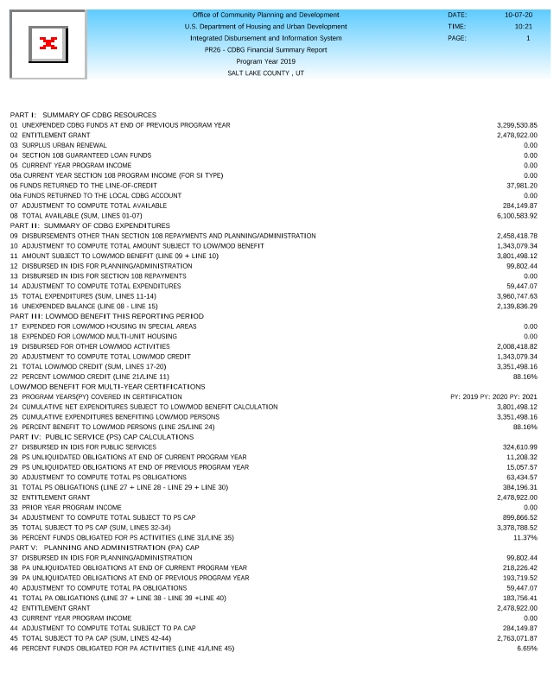
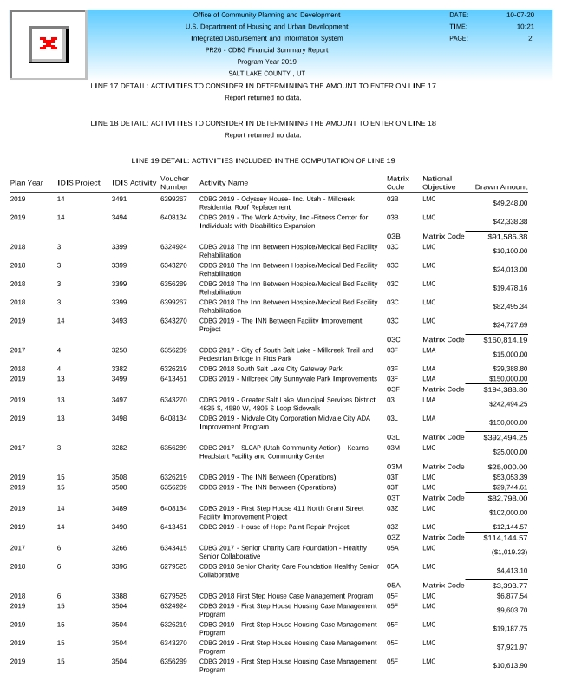
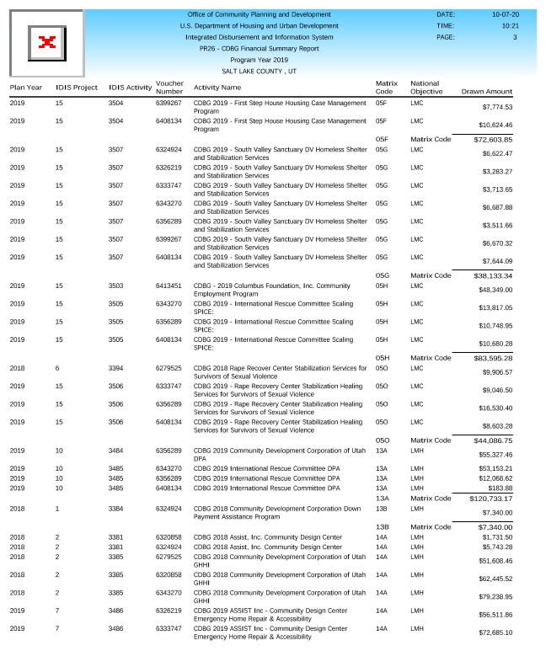
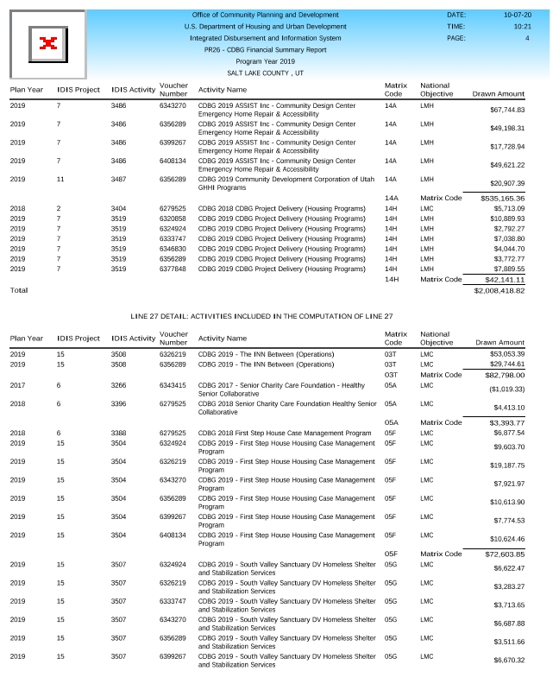
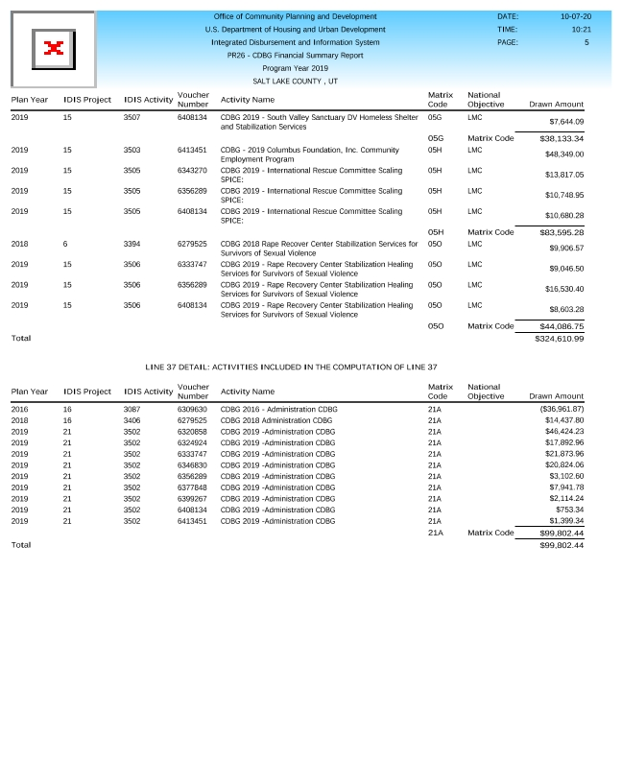

Section 3 Summary Report - CDBG / HOME / LBP
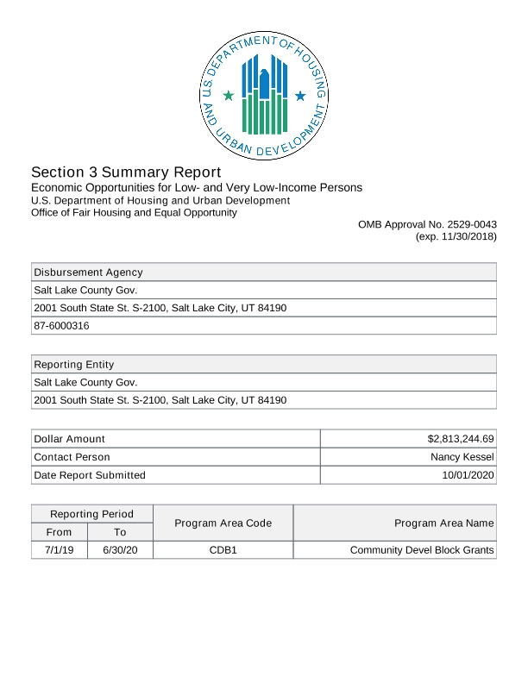
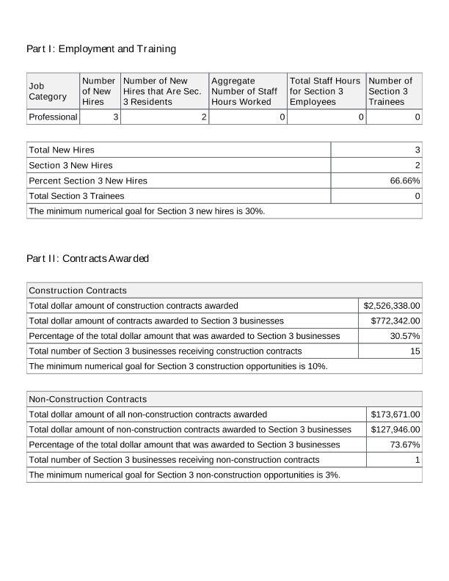
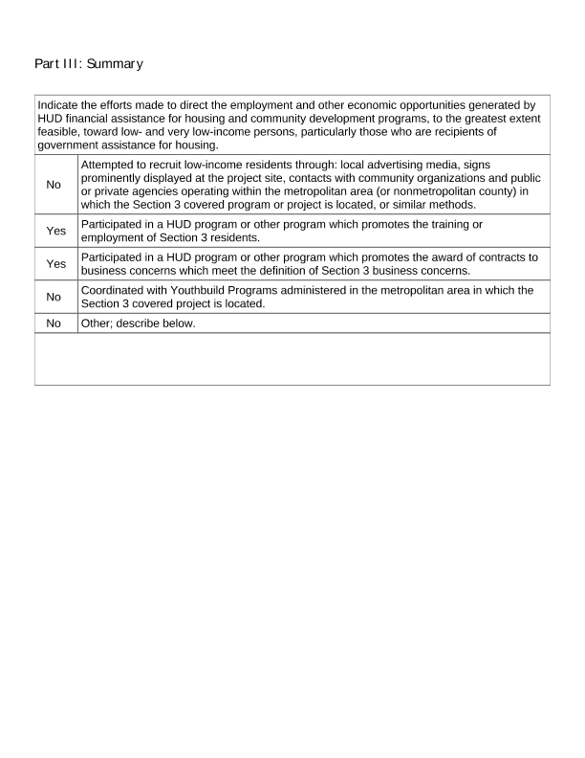

ESG CAPER - SAGE Report
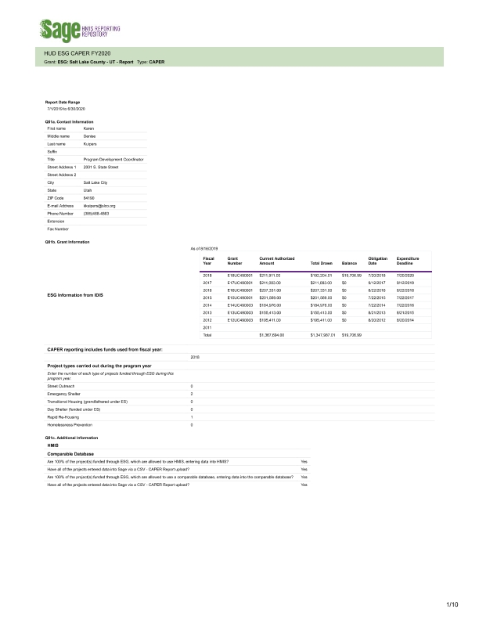
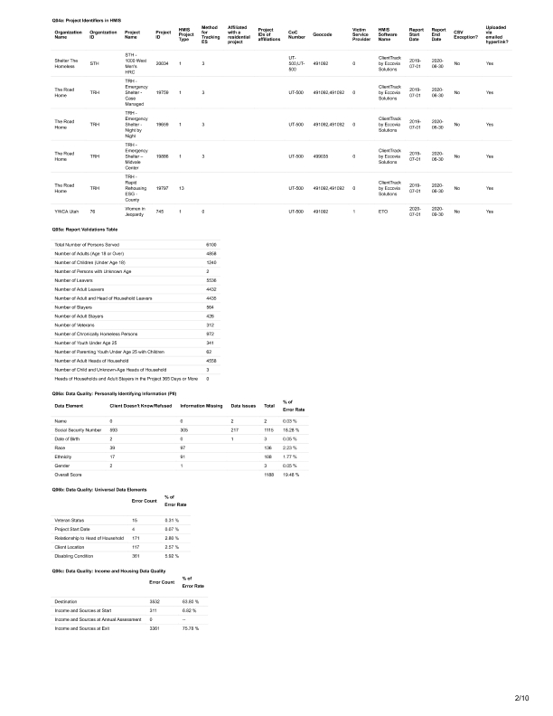
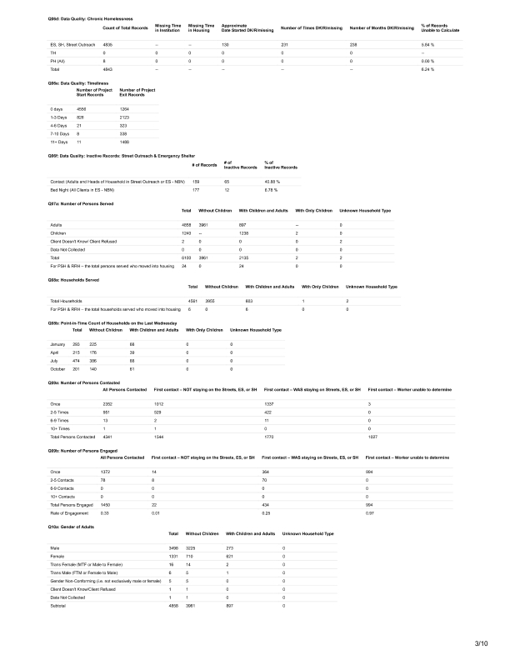
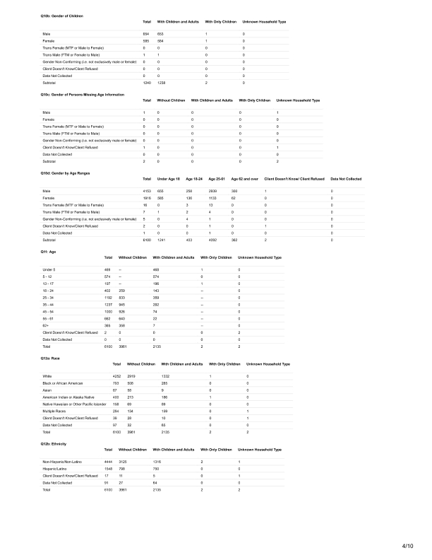
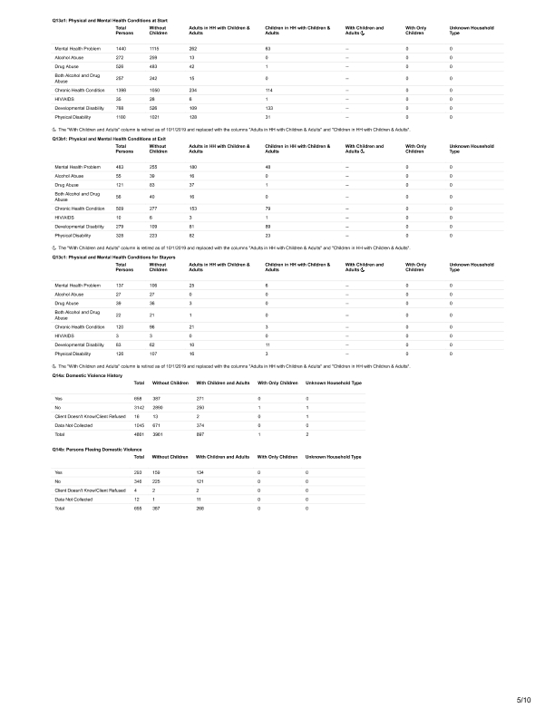
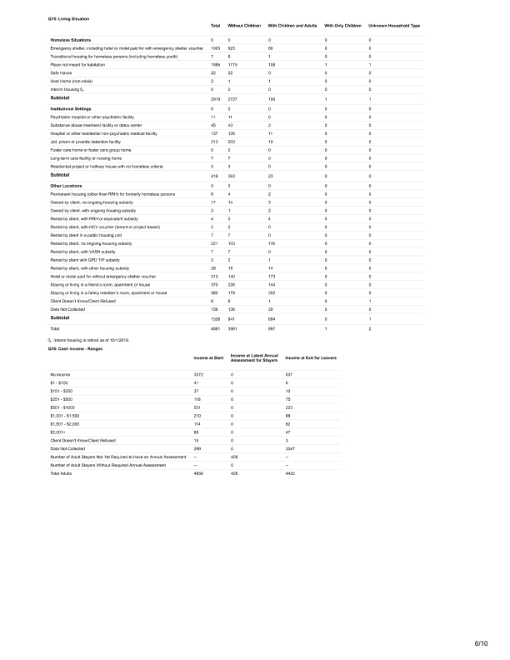
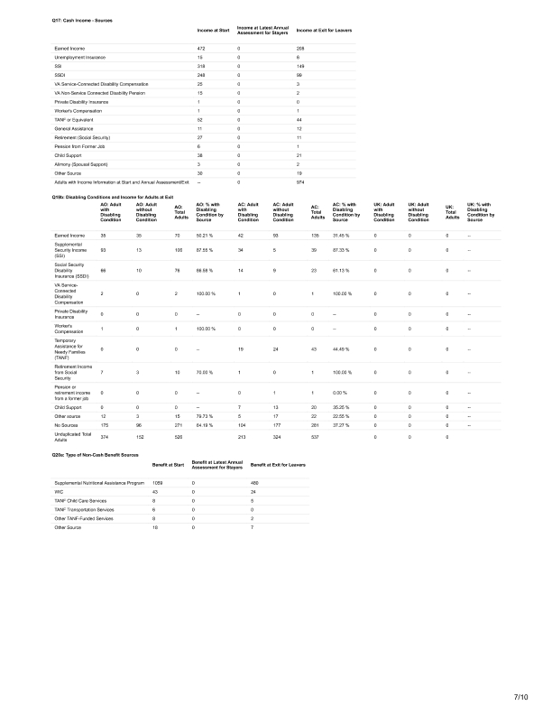
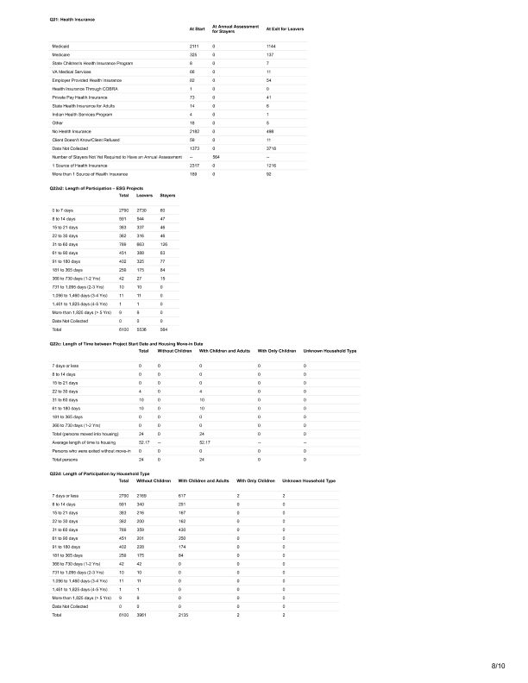
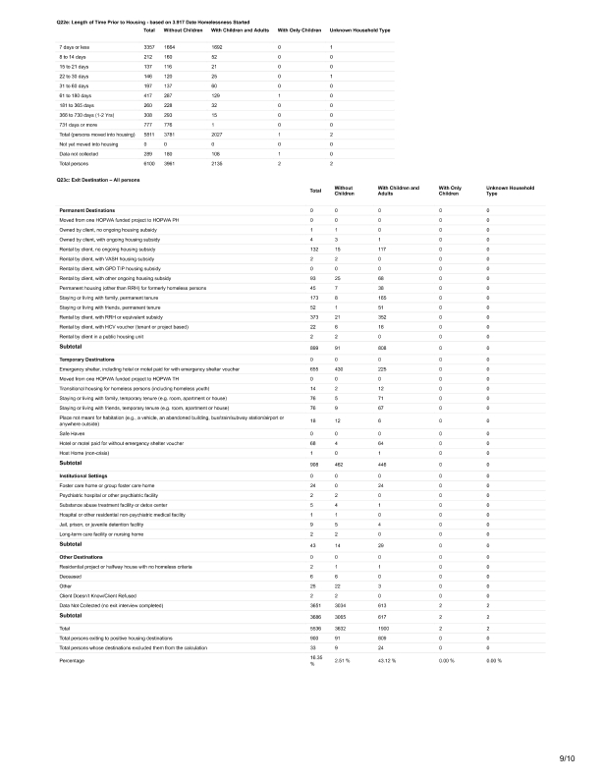
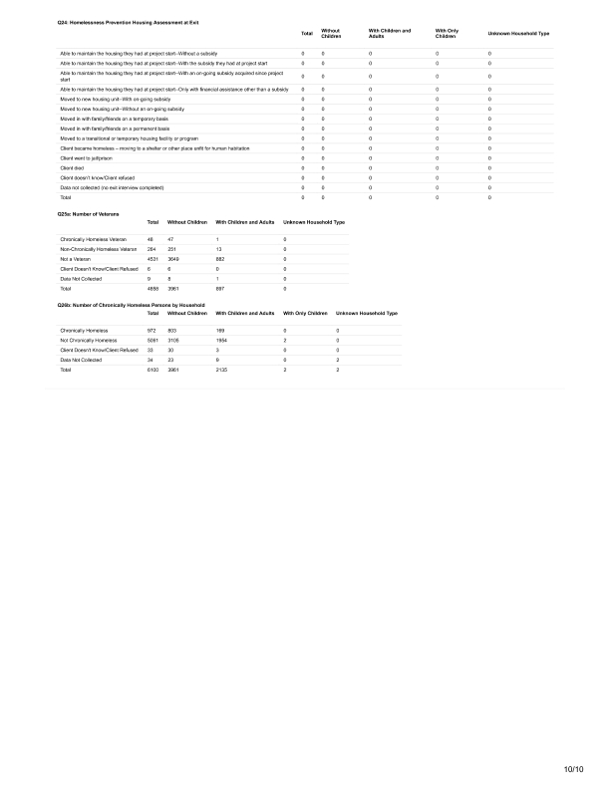

2019-2020 CAPER Proof of Publication (No Comments Received)
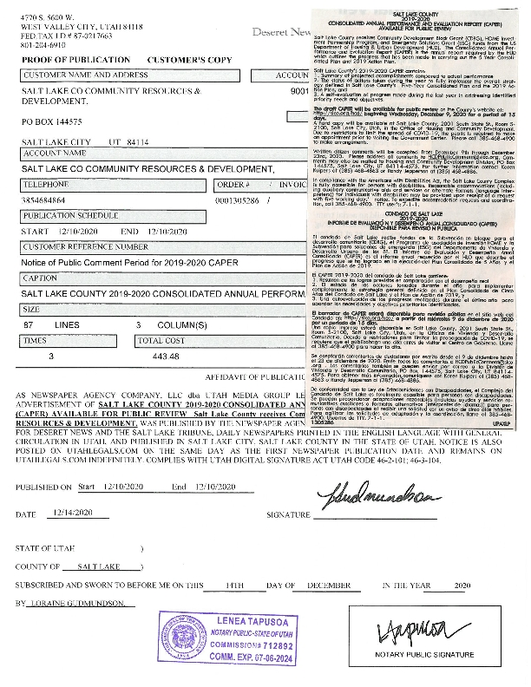

Salt Lake County Housing Achievements Report 2019-2020
